EBook4U

Software Development Plan

Version <1.2>

Revision History

|  |  |  |  |
| --- | --- | --- | --- |
| **Date** | **Version** | **Description** | **Author** |
| 20/10/2022 | 1.0 | Create requirements document (PA0) | Vu Hoang Phuc |
| 27/10/2022 | 1.1 | Write Software Developing Plan | Vu Hoang Phuc |
| 15/11/2022 | 1.2 | Update Software Developing Plan PA2 | Vu Hoang Phuc |
|  |  |  |  |
|  |  |  |  |

Table of Contents

**1. Introduction** **4**

**2. Project Overview** **4**

*2.1 Project Purpose, Scope, and Objectives* *4*

*2.2 Assumptions and Constraints* *4*

*2.3 Project Deliverables* *4*

**3. Project Organization** **5**

*3.1 Organizational Structure* *5*

*3.2 Roles and Responsibilities* *5*

**4. Management Process** **5**

*4.1 Project Estimates* *5*

*4.2 Project Plan* *5*

4.2.1 Phase and Iteration Plan 5

4.2.2 Releases 6

4.2.3 Project Schedule 6

*4.3 Project Monitoring and Control* *7*

4.3.1 Reporting 7

4.3.2 Risk Management 7

4.3.3 Configuration Management 7

Software Development Plan

# 

# Introduction

This document describes the development step by step. It covers planning, ideation, development, deployment, launch and maintenance.

# 

# Project Overview

## Project Purpose, Scope, and Objectives

* **Purpose:** Provide a website for people to read books online.
* **Scope:** Everyone can access and read books easily.
* **Objectives:** Create a website to read books online.

## Assumptions and Constraints

* Project has 5 people, there will be no more people added during the project.
* The project will be completed on time.
* Team members have skills about html, css, javascript, nosql, git.
* Each sprint will occur in about 2 weeks.
* The technology used: coding in IDE Visual Studio Code, managing source in GitHub, meeting in google meet, creating documents in Microsoft word.
* Zero-budget project.
* The project will be done in 3 months.
* Environment working: remote, sometime offline to meet and discuss.

## Project Deliverables

* Weekly Report: every 2 weeks
* Requirements Preview: 20/10/2022
* Vision document: 2/11/2022
* Developing plan: 2/11/2022
* Design, Data Model: 16/11/2022
* UI Design Finish: 29/11/2022
* Test Plan: 26/12/2022
* Project Deliver dates: 28/12/2022

# Project Organization

## Organizational Structure

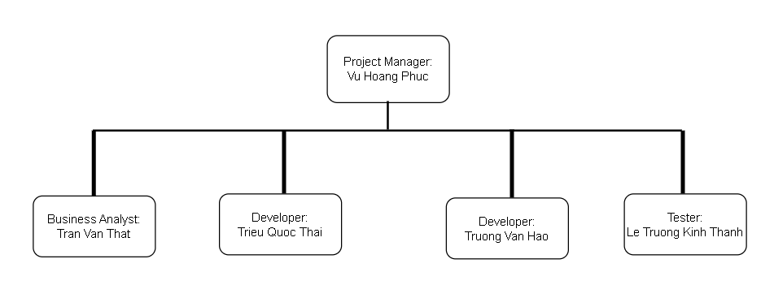

## Roles and Responsibilities

|  |  |
| --- | --- |
| **Person** | **Role** |
| Vu Hoang Phuc, Project Manager | Write project plan(including assign tasks)  Monitor and report status (sprint report)  Coordinate meetings  Contact point for the project |
| Tran Van That, BA | Document requirement (interview customer,etc)  Communicate with team members about the requirements  Coordinate to review requirements |
| Le Truong Kinh Thanh, Tester | Execute and log the tests, evaluate the results and document problems found |
| Trieu Quoc Thai, Developer | Writing and implementing software code  Managing software |
| Truong Van Hao, Developer | Writing and implementing software code  Managing software |

# Management Process

## Project Estimates

## Project Plan

### Phase and Iteration Plan

5 phases of the project:

**Inception:**

PA1 (21/10/2022 - 02/11/2022): Project plan, vision document, weekly report

**Elaboration:**

PA2: (03/11/2022 - 16/11/2022)

PA3: (17/11/2022 - 30/11/2022)

Revised project plan, vision document

Use case document with a revised use case model

Design document (including UI prototypes, architecture document)

Test plan

Weekly reports

**Construction:**

PA4: (01/12/2022 - 14/12/2022)

PA5: (15/12/2022 - 28/12/2022)

Revised artifacts submitted in Elaboration

Test cases

Source code

Test report

Defects

Weekly reports

Presentation + Demo

### Releases

* Demo : Complete basic of website interface, basic functions such as reading books, evaluating

Date: 28/12/2022

* Beta: Provide user testing experience, categorizes and offers more books

Date: 1/2023

### Project Schedule

## Project Monitoring and Control

### Reporting

* Meeting online
* Chatting in slack,messenger

### Risk Management

|  |  |  |  |  |  |  |
| --- | --- | --- | --- | --- | --- | --- |
| Risk ID | Risk Description | Probability | Impact | Risk Exposure | Priority | Mitigation Strategy or Contingency Plan |
|  |  |  |  | =Probability * Impact |  |  |
|  |  |  |  |  |  |  |
|  |  |  |  |  |  |  |

### Configuration Management

* Google Drive for storing and sharing documents and files
* Github to manage source code and related files
* Google Meet for meeting and discussing
* Jira for assigning the task
* Slack for chatting and discussing
* Figma for designing UX/UI
* Visual Studio Code for coding
* Trello to schedule the task